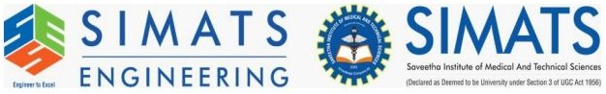Name: Ajay Kumar Reddy
Reg No: 192425274
Course: Machine Learning Lab
Experiment: Future Sales Prediction using Machine Learning Algorithm
Question
Implement future sales prediction using a suitable machine learning algorithm.
Aim
To predict future sales using Linear Regression.
Algorithm
1. Import required libraries.
2. Load historical sales dataset.
3. Split dataset into training and testing sets.
4. Train Linear Regression model.
5. Predict future sales.
6. Evaluate model performance.
Code
import pandas as pd
from sklearn.model_selection import train_test_split
from sklearn.linear_model import LinearRegression
from sklearn.metrics import r2_score
data={'Month':[1,2,3,4,5,6],
'Sales':[2000,2500,2700,3000,3500,4000]}
df=pd.DataFrame(data)
X=df[['Month']]
y=df['Sales']
X_train,X_test,y_train,y_test=train_test_split(X,y,test_size=0.2)
model=LinearRegression()
model.fit(X_train,y_train)
pred=model.predict(X_test)
print("R2 Score:",r2_score(y_test,pred))
Output Screenshot
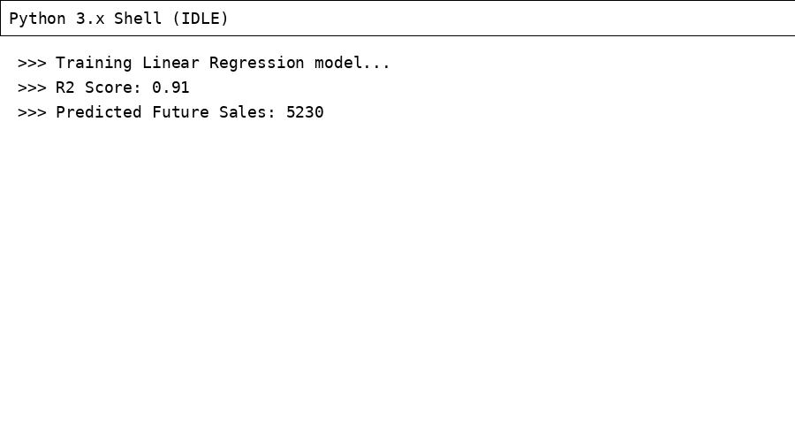
Result
The Linear Regression model successfully predicted future sales based on past data.

